**Qwen2-VL and Llama3.2 Vision Comparison:**

**Comparison Table:**

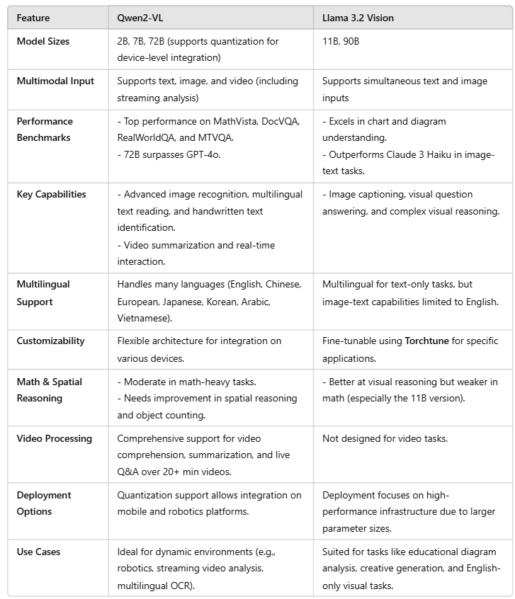

**Strengths:**

* **Qwen2-VL:**
* Comprehensive video capabilities and robust multilingual support.
* Strong integration with edge devices due to quantization options.
* **Llama 3.2 Vision:**
* Superior performance in chart and diagram-based tasks.
* Flexible fine-tuning framework for tailored applications.

**Weaknesses:**

* **Qwen2-VL:**
* Struggles with object counting and complex spatial reasoning.
* Multi-step instruction execution could be improved.
* **Llama 3.2 Vision:**
* Limited multilingual support for image+text tasks.
* Math reasoning capabilities lag behind in the smaller model (11B).

**Which Model to Choose?**

**Qwen2-VL:** Best for applications requiring real-time video analysis, multilingual document understanding, or deployment on edge devices.

**Llama 3.2 Vision:** Ideal for English-centric use cases, requiring precision in chart/diagram interpretation or fine-tuned multimodal models for enterprise tasks.